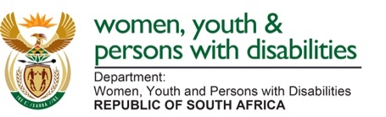 

**MEDIA ADVISORY**

**Issued by the Department of Women, Youth and Persons with Disabilities  
Attention: Journalists and News Editors  
Friday: 13 September 2024**  
**……………………………………………………………………………………………..............**

**DEPUTY MINISTER LETSIKE WILL ADDRESS THE DISABLED PEOPLE SOUTH AFRICA 40TH ANNIVERSARY CELEBRATION.**

**Pretoria:** Deputy Minister in the Presidency for Women, Youth and Persons with Disabilities, Mmapaseka Letsike will address the 40th Anniversary celebration of Disabled People South Africa (DPSA) at Birchwood Hotel Conference Centre in Boksburg, on Friday 13 September 2024. South Africa has a population of 62 million persons, with around 3,3 million individuals identified as living with disabilities.

**Members of the media are invited to cover the event as follows:**

Date: 13 September 2024

Time: 19:00-20:00

Venue: Birchwood Hotel Conference Centre in Boksburg

Disabled People South Africa (DPSA) is a nonprofit and democratic cross-disability body made up of member organisations of disabled people that mobilise and advocate for their rights for the attainment of equal opportunity. The White Paper on the rights of persons with disabilities calls to action for government, civil society and the private sector to work together to ensure the socio-economic inclusion of persons with disabilities.

**END**

***Issued by: Department of Women, Youth and Persons with Disabilities.***

***Media Enquiries: Director Communications Cassius Selala***

***Tel: 060 534 0672***