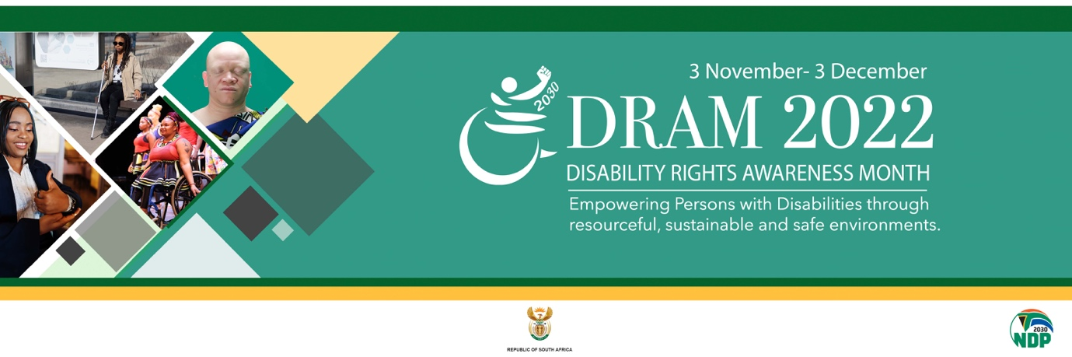

Key messages

- “Leave no one behind!”
- Person with disabilities voices matter! Listen and engage.
- Elevate persons with disabilities with decent jobs not donations.
- Barrier-free and safe environments for everyone! Persons with disabilities included.
- If it’s not disability inclusive, it’s not inclusion. (No inclusion without disability inclusion.)
- Disability rights are human rights.
- Disability is not an issue! Stand against disability discrimination.
- Moving towards 100% disability-friendly and accessible public transport.
- Whether your disability is visible or invisible, seek support!

- Empowering persons with disabilities empowers South Africa to achieve more.
- Empowerment of persons with disabilities in resourced and sustainable environments is a right.
- Make communication with me accessible.
- Prioritise me - my health is just as important.
- Include me when making decisions on my behalf.
- Make empowerment opportunities inclusive of me.
- Capacitate me so I can be an active contributor to the economy.
- Don’t be ignorant, no one is immune to acquiring a disability
- My disability does not stop me from doing what I want or what I want to achieve.
- My disability does not define my ambitions, identity or motivations.
- Know me for me and my ability, not my disability
- Your attitude towards me is my biggest disability
- An empowered disability sector can contribute to a better South Africa.

